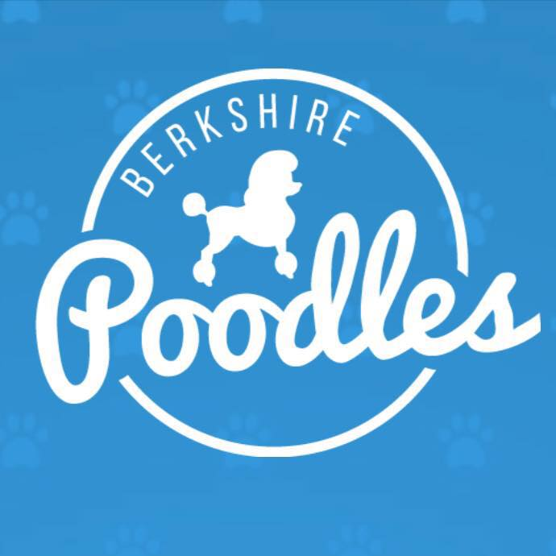
Lee & Kaitlyn Kohlenberger
26 Harryel St
Pittsfield, MA, 01201
Lee (413)464-1216
Kate (413)441-2925
BerkshirePoodles@gmail.com

Berkshire Poodles Sales Agreement and Contract
This Agreement made by and between Lee & Kaitlyn Kohlenberger, AKA Berkshire Poodles; be it known that all references to Berkshire Poodles is synonymous with Lee & Kaitlyn Kohlenberger, and (Purchaser) You, is legally binding and properly executed. All further references to ‘you’ in the contract mean the purchaser. You and Berkshire Poodles make the following essential and critical warranties to each other:
Litter Information:
Sire: WAIT LIST! TBD
Dam: WAIT LIST! TBD
Date of Birth: Due 00/00/0000
Color Possibilities: Black, Blue, Silver, Brown, Red, Apricot, Cream and or White
Purchase Price: $2,500.00

Puppy Preferences for wait list contract:

Sex Preference (select one, if no preference leave blank): MALE / FEMALE

Color Preference (List in order): 1. _______________ 2. _______________ 3. _______________

Special Requests:
__________________________________________________________________________________________
__________________________________________________________________________________________

What is your ideal timeframe for adding a puppy to your family? _____________________________________________

When would you like us to start notifying you about planned litters: __________________________________________

You understand your deposit is nonrefundable but transferable to any Berkshire Poodle litter (initial): __________

Our Commitment to You:
- Puppies are sold with AKC limited registration only unless agreed upon to a show or breeding home. In which case you will need a different contract.

- This puppy is guaranteed to be in good health and properly vaccinated and de-wormed. Berkshire Poodles will provide accurate health records of this puppy. This guarantee is applicable to only the original purchaser for three days.

- Your puppy should be examined by a licensed veterinarian within 72 hours (three days) after being delivered to or picked up by you (breeder not responsible for vet bills). If this puppy is found to have serious life-threatening illness or disease (excluding common parasites or coccidian) the breeder will replace the puppy with one of equal value when available. Berkshire Poodles requires that the puppy be returned with documented proof of said illness or disease from a licensed veterinarian within seven (7) days of purchase (breeder not responsible for transportation costs.) Berkshire Poodles reserves the right to have the puppy examined by a licensed veterinarian of its choice to verify diagnosis before replacing the puppy. The contract is null and void if a veterinarian has not been consulted in 72 hours or if the puppy is harmed due to mishandling.

- This puppy is guaranteed to you (the original purchaser) for three (3) years against hereditary and/or genetic diseases. If your puppy is found to have serious hereditary and/or genetic disease, Berkshire Poodles will replace the puppy with one of equal value when available. Documentation of said diseases from a licensed veterinarian is required. Berkshire Poodles reserves the right to have the puppy examined by a licensed veterinarian of its choice to verify diagnosis before replacing. If Berkshire Poodles have no litters planned within one year of date of notification, a refund of purchase price will be given. The option of keeping said puppy or returning him/her to us will be decided individually by Berkshire Poodles. Shipping costs, if applicable, will be your responsibility.

- These puppies do not come trained; however, they will be socialized with other dogs, people and situations and will be accustomed to handling and grooming. We put every effort into starting your puppy off on a solid foundation physically, mentally and emotionally. You MUST spend time with your new poodle to help form him/her into the dog you want it to be.

- Berkshire Poodles uses a limited vaccination protocol. The 5 Way Shot MLV (distemper & parvovirus) will be given at 8 weeks and should be given again at 12 and 16 weeks and again at one (1) year old; and then follow up shots every (3) three years thereafter. Rabies vaccine should be given according to your state’s laws BUT SHOULD NEVER be given on same day as other vaccines, it is best to have four (4) weeks difference between vaccines. Your puppy will have had its 7-week shot at minimum.

- Berkshire Poodle puppies are raised on PRO PLAN FOUCS Dog Foods. The following foods are the other options we approve: Fromm, Merrick, Orijen, Acana, Purina Pro Plan or Life’s Abundance. One of these brands must be fed within the first 3 years of life in order to keep any health warranty intact. No food containing PEAS, LENTILS or CHIC PEAS should be fed at any time. These are common ingredients in Grain Free dog food so be careful what you buy if you switch from Fromm Puppy Chicken & Rice or Pro Plan Salmon for Sensitive Skin and Stomachs.

Your Commitment to Berkshire Poodles:
You represent that no member of your family has ever been charged with cruelty to animals and agree to accept the following conditions and restrictions:

Purchaser’s Name: __________________________________________________________________________________________

Purchaser’s home address: ____________________________________________________________________________________________________________________________________________________________________________________

Purchaser’s Best Contact number: __________________________________________________________________________________________

Purchaser’s Email: __________________________________________________________________________________________

- You confirm that this puppy will be properly housed, fed, watered and exercised and that appropriate veterinary attention will be provided for it if/when required. You further acknowledge that the animal will not be permitted to roam at large or to cause a nuisance to neighbors or those carrying out official duties. When away from home, you will ensure that the dog is kept leashed or under effective verbal control.

- Berkshire Poodles strongly encourages that the puppy be taken to training/socialization classes. This can only benefit both owner and puppy, enriching the lives of all involved. We strongly encourage that you work your puppy in some type of discipline such as obedience, agility, rally. Any owner who competes in AKC sanctioned disciplines and puts a title on their dog such as an Obedience CD will receive a $50 refund from Berkshire Poodles. This will be a one-time refund.

- If, for any reason you cannot keep your puppy/dog, Berkshire Poodles has first right of refusal. You guarantee that the puppy will not be transferred to a third party, without the express permission of Berkshire Poodles in writing. We are here to help you if you need to find a new home for your Berkshire Poodle.

- You agree that if in the future, the terms of this Agreement can no longer be met, or, if you violate any of the provisions of this Agreement, you will surrender custody of your puppy/dog to Berkshire Poodles with NO Refund, any costs related to the surrender of your puppy/dog to Berkshire Poodles due to your violation of this Agreement, are your sole responsibility.

- You agree that this puppy/dog is being purchased as a pet only. You agree to have this dog altered (spayed or neutered) between the ages of eight months and one year of age. We here at Berkshire Poodles believe that the puppy needs its hormones to help it mature properly. All care should be taken to avoid accidental breeding until alteration can be performed.

- You agree to provide us with your Veterinarian’s information and you agree to update us if that information changes. You also agree to allow us to check on the health of your puppy and to allow your veterinarian to release information to us the breeder.

Vet Name and Number: _________________________________________________________________________________

Signed by the Breeder: Dated: / /
Signed by The Purchaser: Dated: / /

Payment Schedule:
Make All Checks Payable to:
LEE KOHLENBERGER

Deposit & Date: $500.00 ____/____/________ (THIS IS IMPORTANT)
Total Purchase Price: $2,500.00

You’re also welcome to make payments via Venmo @Kaitlyn-Kohlenberger or Zelle at (413)464-1216

All puppies must be paid in full prior to 6 weeks of age. Puppies with natural tails must be paid in full prior to 5 days of age.

UNDER NO CIRCUMSTANCES SHOULD ANY Berkshire POODLE BE USED FOR BREEDING WITHOUT PERMISSION FROM Berkshire Poodles. ANY PERSON(S) FOUND TO BE USING ONE OF Berkshire’s POODLES for breeding without permission, WILL PAY A FINE OF $5,000.00, cover any and all of the breeder’s attorney fees AND THE DOG WILL BE RETURNED TO Berkshire POODLES.

ALL PAYMENTS AND DEPOSITS ARE NON-REFUNDABLE BUT TRANSFERABLE TO FUTURE LITTERS.

By signing this contract, the Buyer(s) confirm(s) that they have read and agree to all the terms set out within the three-four (3-4) pages of this contract.

